**1. Write a JavaScript to design a simple calculator to perform the following operations: sum, product, difference and quotient.**

**index.html**

**<!DOCTYPE html>  
<html lang="en">  
<head>  
 <meta charset="UTF-8">  
 <title>Simple Calculator</title>  
 <script type="text/javascript">  
  
 var exp="",res=0;  
 function insert(val)**

**{  
 document.getElementById('res').value+=val;  
 }  
 function calculate()  
 {  
 exp=document.getElementById('res').value;  
 res=eval(exp);  
 document.getElementById('res').value=res;  
 }  
 function reset()  
 {  
 document.getElementById('res').value="";  
 }  
 </script>  
 <style type="text/css">  
 input {width: 100%}  
 h1 {text-align: center}  
 </style>  
</head>  
<body onload="reset()">  
 <h1>Simple Calculator</h1>  
 <table align="center" border="1">  
 <tr>  
 <td colspan="5"><input type="text" id="res" name="res" value="" /></td>  
 </tr>  
 <tr>  
 <td><input type="button" value="7" onclick="insert('7')" /></td>  
 <td><input type="button" value="8" onclick="insert('8')" /></td>  
 <td><input type="button" value="9" onclick="insert('9')" /></td>  
 <td><input type="button" value="+" onclick="insert('+')" /></td>  
 <td><input type="button" value="-" onclick="insert('-')" /></td>  
 </tr>  
 <tr>  
 <td><input type="button" value="4" onclick="insert('4')" /></td>  
 <td><input type="button" value="5" onclick="insert('5')" /></td>  
 <td><input type="button" value="6" onclick="insert('6')" /></td>  
 <td><input type="button" value="*" onclick="insert('*')" /></td>  
 <td><input type="button" value="/" onclick="insert('/')"/></td>  
 </tr>  
 <tr>  
 <td><input type="button" value="1" onclick="insert('1')" /></td>  
 <td><input type="button" value="2" onclick="insert('2')" /></td>  
 <td><input type="button" value="3" onclick="insert('3')" /></td>  
 <td><input type="button" value="0" onclick="insert('0')" /></td>  
 <td><input type="button" value="=" onclick="calculate()" /></td>  
 </tr>  
 <tr>  
 <td colspan="5"><input type="button" size="100%" value="CLEAR" onclick="reset()" /></td>  
 </tr>  
 </table>  
</body>  
</html>**

**Output :**

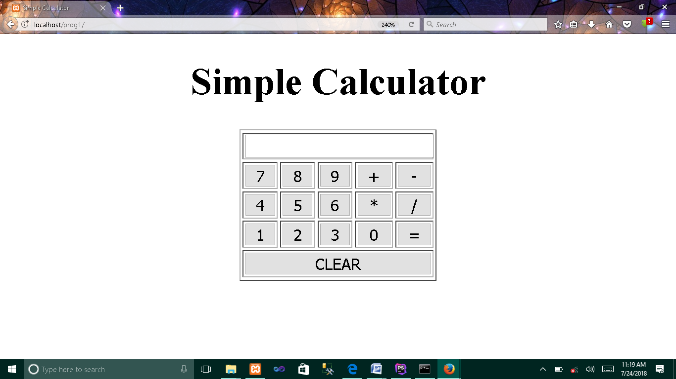

**2. Write a JavaScript that calculates the squares and cubes of the numbers from 0 to 10 and outputs HTML text that displays the resulting values in an HTML table format.**

**index.html**

**<!DOCTYPE html>  
<html lang="en">  
<head>  
 <meta charset="UTF-8">  
 <title>Program for Squares and Cubes</title>  
 <style type="text/css">  
 table,h1 {text-align: center}  
 </style>  
</head>  
<body>  
<h1>Program to find Square and Cube</h1>  
<script type="text/javascript">  
 var mytable="<table border='1' align='center'> <tr> <th>Number</th>**

**<th>Square</th> <th>Cube</th> </tr>";  
 var square= 0,cube=0;  
 for(var i=0;i<=10;i++)  
 {  
 square=i*i;  
 cube=i*i*i;**

**mytable+="<tr><td>"+i+"</td><td>"+square+"</td>**

**<td>"+cube+"</td></tr>"  
 }  
 mytable+="</table>";  
 document.write(mytable);  
</script>  
</body>  
</html>**

**Output :**

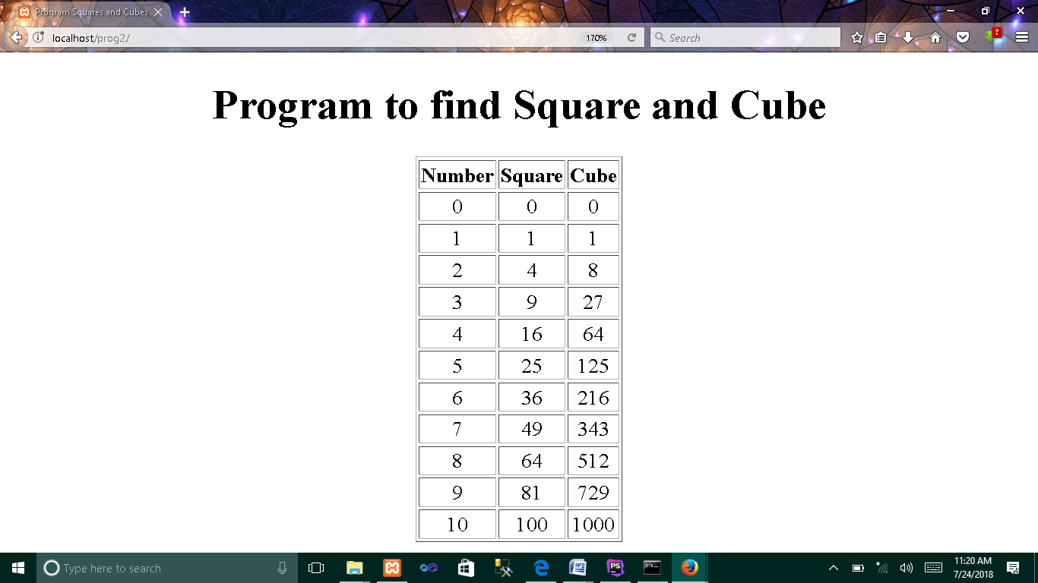

**3. Write a JavaScript code that displays text “TEXT-GROWING” with increasing font size in the interval of 100ms in RED COLOR, when the font size reaches 50pt it displays “TEXT-SHRINKING” in BLUE color. Then the font size decreases to 5pt.**

**index.html**

**<!DOCTYPE html>  
<html lang="en">  
<head>  
 <meta charset="UTF-8">  
 <title>Prog for Text Animation</title>  
 <script type="text/javascript">  
 function *animate*()  
 {  
 var fontsize=5;  
 var state="growing";  
 var timer=setInterval(*textanimate*,100);  
 function *textanimate*()  
 {  
 if(state=="growing")  
 {  
 fontsize++;  
 document.getElementById('text').innerHTML="TEXT GROWING";  
 document.getElementById('text').style.color="red";**

**document.getElementById('text').style.fontSize=fontsize+"pt";  
 }  
 if(state=="shrinking")  
 {  
 fontsize--;  
 document.getElementById('text').innerHTML="TEXT SHRINKING";  
 document.getElementById('text').style.color="blue";**

**document.getElementById('text').style.fontSize=fontsize+"pt";  
 }  
 if(fontsize==50)  
 {  
 state="shrinking"  
 }  
 if(fontsize==5)  
 {  
 clearInterval(timer);  
 }  
 }  
 }  
 </script>  
</head>  
<body onload="*animate*()">  
 <h1 style="text-align: center">**

**Program for Increasing / Decreasing size of a text**

**</h1>  
 <p style="text-align: center;" id="text"></p>  
</body>  
</html>**

**Output :**

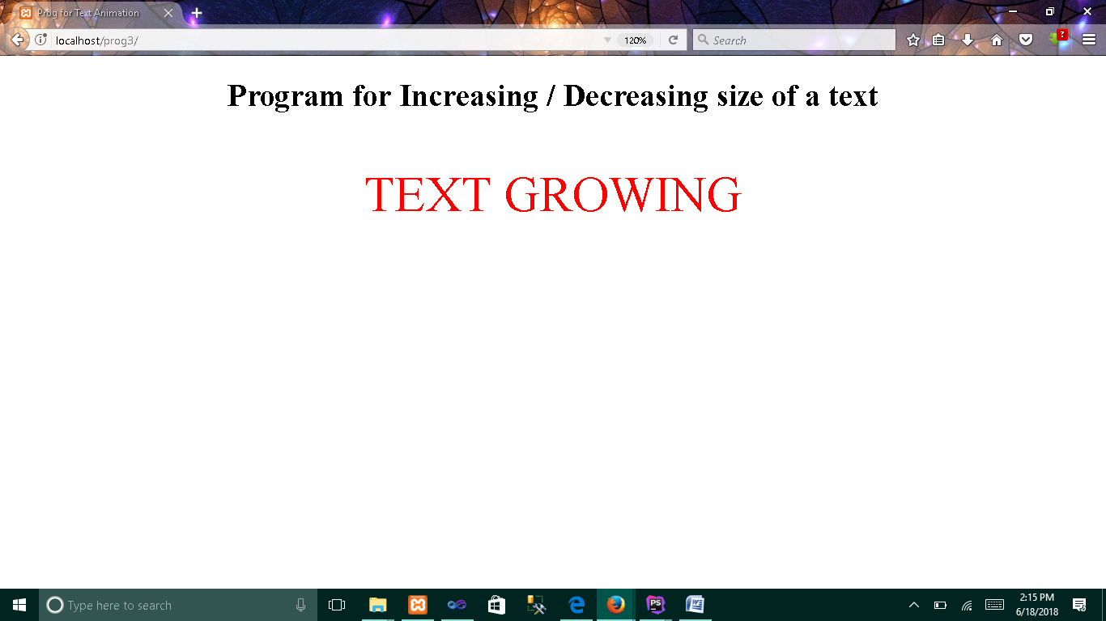

1. **Animation for text growing**

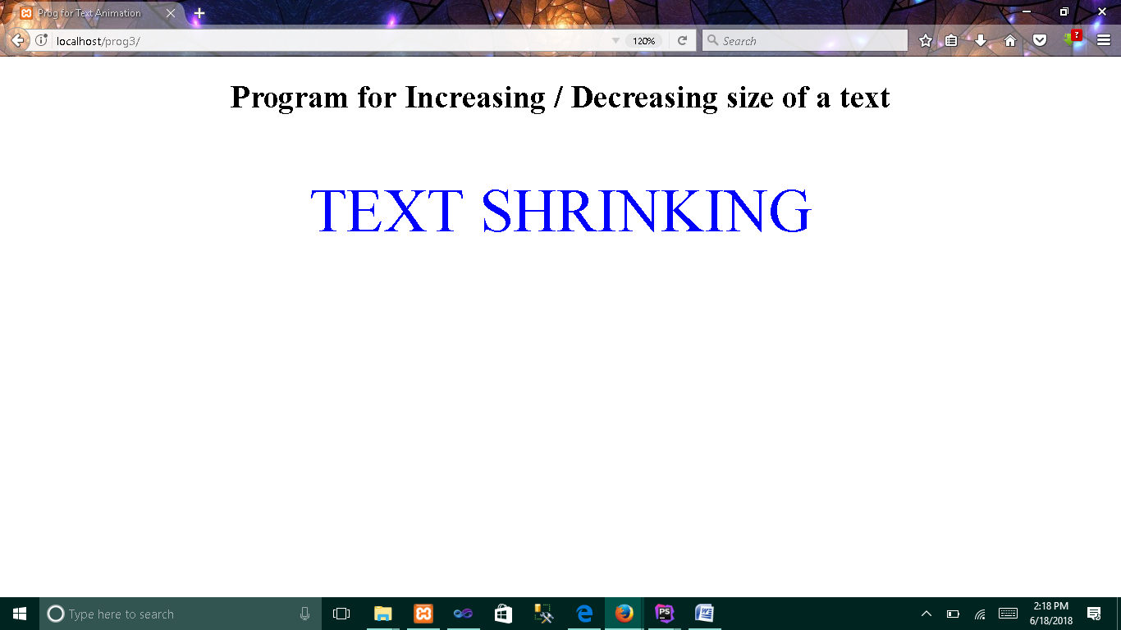

1. **Animation for text shrinking**

**4. Develop and demonstrate a HTML5 file that includes JavaScript script that uses functions for the following problems:**

**a. Parameter: A string**

**b. Output: The position in the string of the left-most vowel**

**c. Parameter: A number**

**d. Output: The number with its digits in the reverse order**

**index.html**

**<!DOCTYPE html>  
<html lang="en">  
<head>  
 <meta charset="UTF-8">  
 <title>Program to find leftmost vowel and digits in reverse order</title>  
 <script type="text/javascript">  
 function *validate*()  
 {  
 var inp=document.getElementById('val').value;  
 if(isNaN(inp))  
 *findVowel*(inp);  
 else  
 *findReverse*(inp);  
 }  
 function *findVowel*(inp)  
 {  
 var str=inp.toLowerCase();  
 var pos=0,ch="";  
 for(var i=0;i<str.length;i++)  
 {  
 ch=str.charAt(i);  
 if(ch=="a"||ch=="e"||ch=="i"||ch=="o"||ch=="u")  
 {  
 pos=i+1;  
 break;  
 }  
 }  
 if(pos==0)  
 alert("Vowel not found");  
 else  
 alert("Position of Left Most Vowel in the string : "+pos);  
 }  
 function *findReverse*(inp)  
 {  
 var num=parseInt(inp);  
 var temp=num;  
 var rem= 0,rev= 0;  
 while(num>0)  
 {  
 rem=num%10;  
 rev=rev*10+rem;  
 num=parseInt(num/10);  
 }  
 alert("Number : "+temp+"\nReverse Order : "+rev);  
 }  
 </script>  
</head>  
<body>  
 <h1>**

**Program to find left most vowel or Digits in reverse order**

**</h1>  
 <input type="text" name="val" id="val" placeholder="Enter String or Digits">  
 <input type="button" value="submit" onclick="*validate*()">  
</body>  
</html>**

**Output :**

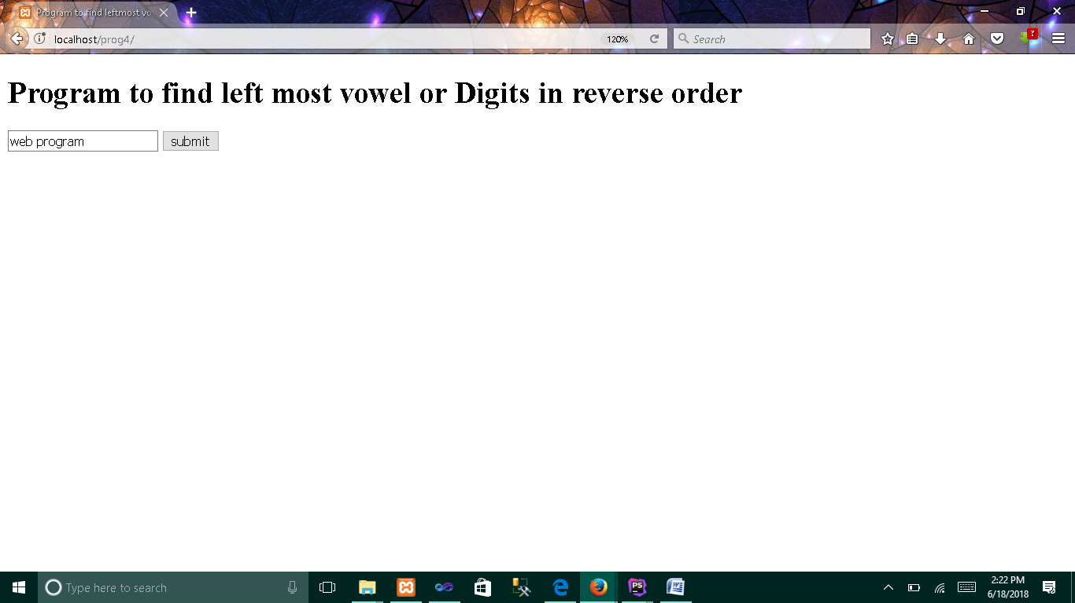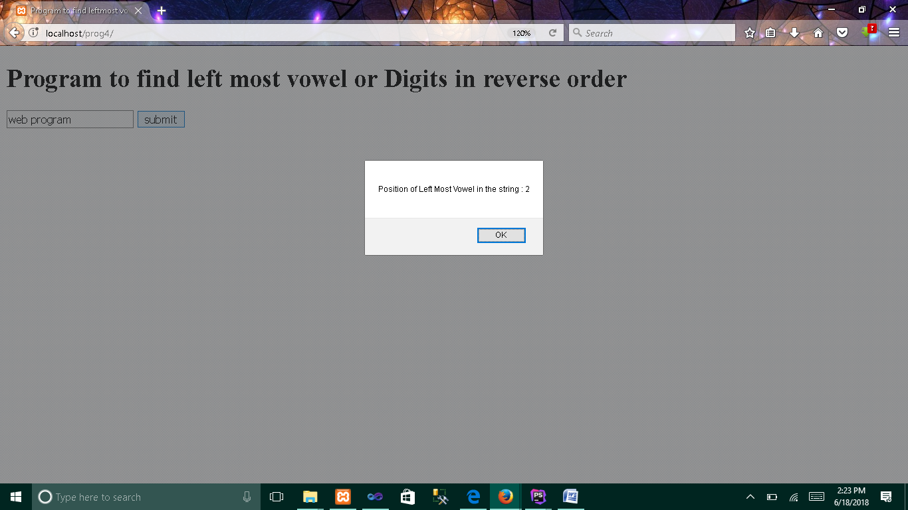

1. **When you enter the string as input**

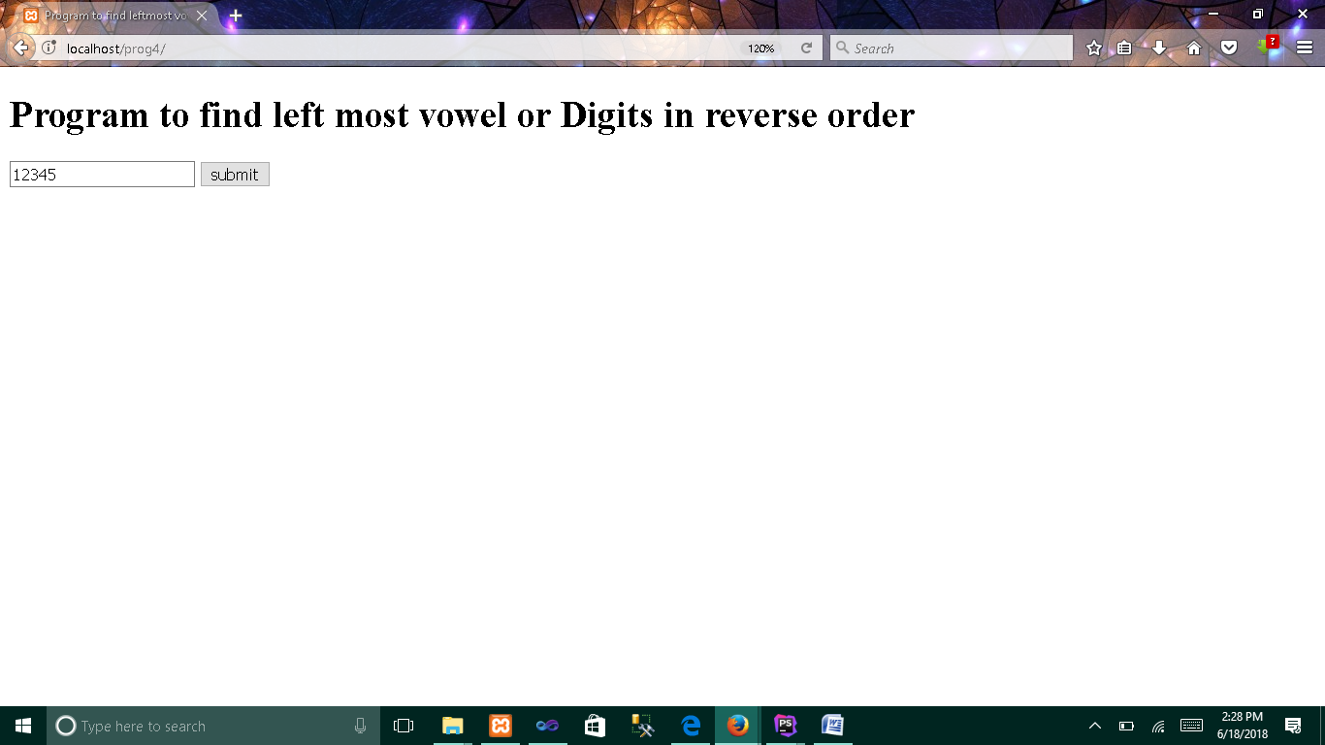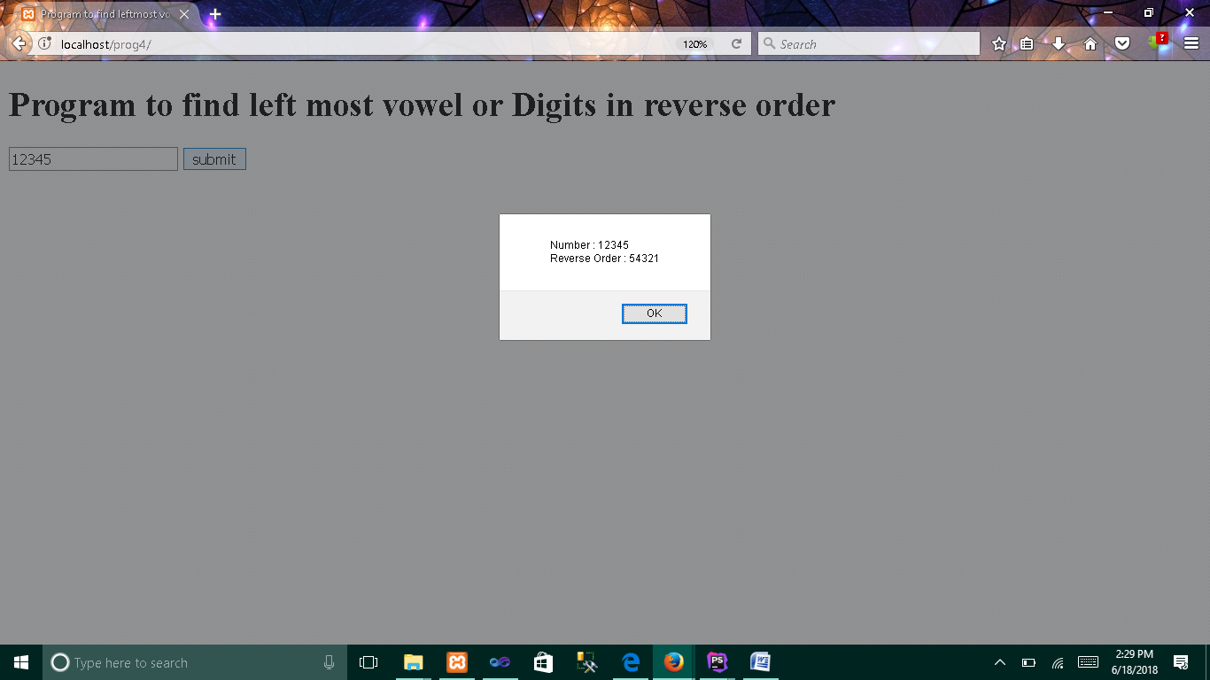

1. **When you enter the digits as input**

**5. Design an XML document to store information about a student in an engineering college affiliated to VTU. The information must include USN, Name, and Name of the College, Branch, Year of Joining, and email id. Make up sample data for 3 students. Create a CSS style sheet and use it to display the document.**

**5.xml**

***<?*xml version="1.0" encoding="UTF-8"*?>  
<?*xml-stylesheet type="text/css" href="5.css"*?>*<!DOCTYPE student [  
 <!ELEMENT student_info (h1,h2+,ad+)>  
 <!ELEMENT ad (label)>  
 <!ELEMENT usn (#PCDATA)>  
 <!ELEMENT name (#PCDATA)>  
 <!ELEMENT col (#PCDATA)>  
 <!ELEMENT branch (#PCDATA)>  
 <!ELEMENT year (#PCDATA)>  
 <!ELEMENT email (#PCDATA)>  
 <!ELEMENT label (#PCDATA|usn|name|col|branch|year|email)*>  
 <!ELEMENT h2 (#PCDATA)>  
 <!ELEMENT h1 (#PCDATA)>]*>*<student_info>  
 <h1>Student information</h1>**

**<h2>Student1</h2>  
 <ad><label>USN:<usn>4SH11CS001</usn></label></ad>  
 <ad><label>NAME:<name>AAA</name></label></ad>  
 <ad><label>COLLEGE:<col>SDIT</col></label></ad>  
 <ad><label>BRANCH:<branch>CSE</branch></label></ad>  
 <ad><label>YEAR:<year>2011</year></label></ad>  
 <ad><label>EMAIL:<email>abc@gmail.com</email></label></ad>**

**<h2>Student2</h2>  
 <ad><label>USN:<usn>4SH11IS002</usn></label></ad>  
 <ad><label>NAME:<name>BBB</name></label></ad>  
 <ad><label>COLLEGE:<col>SDIT</col></label></ad>  
 <ad><label>BRANCH:<branch>ISE</branch></label></ad>  
 <ad><label>YEAR:<year>2012</year></label></ad>  
 <ad><label>EMAIL:<email>efg@gmail.com</email></label></ad>**

**<h2>Student3</h2>  
 <ad><label>USN:<usn>4SH11CS003</usn></label></ad>  
 <ad><label>NAME:<name>CCC</name></label></ad>  
 <ad><label>COLLEGE:<col>SDIT</col></label></ad>  
 <ad><label>BRANCH:<branch>CSE</branch></label></ad>  
 <ad><label>YEAR:<year>2013</year></label></ad>  
 <ad><label>EMAIL:<email>hij@gmail.com</email></label></ad>  
</student_info>**

**5.css**

**h1 {color:green;font-size:50px;}  
h2 {display:block;margin-left:40px;color:brown;font-size:40px;}  
ad {display:block;margin-left:80px;margin-top:20px;color:blue;font-size:20px;}  
usn {color:red;margin-left:20px;font-size:20px;}  
name {color:red;margin-left:20px;font-size:20px;}  
col {color:red;margin-left:20px;font-size:20px;}  
branch {color:red;margin-left:20px;font-size:20px;}  
year {color:red;margin-left:20px;font-size:20px;}  
email {color:red;margin-left:20px;font-size:20px;}**

**Output :**

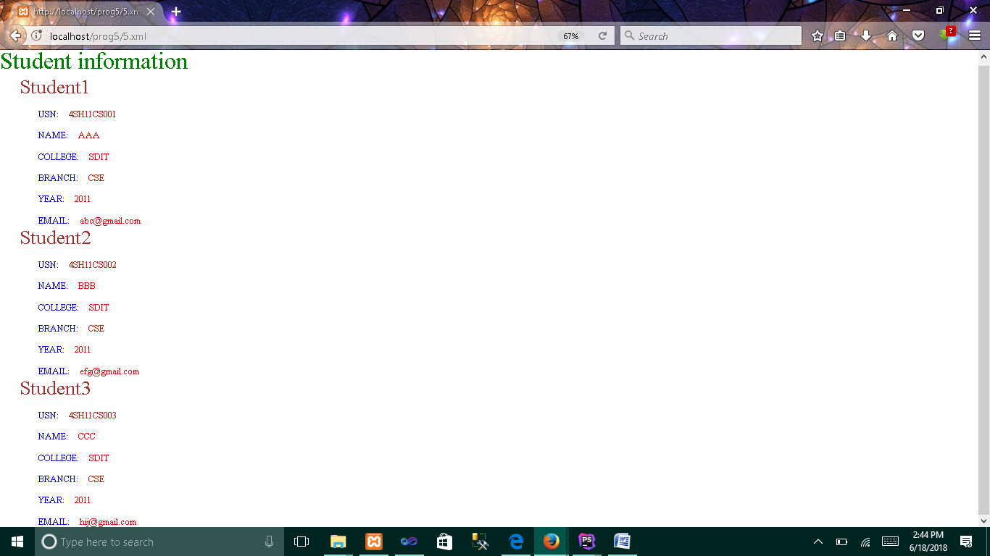

**6.Write a PHP program to keep track of the number of visitors visiting the web page and to display this count of visitors, with proper headings.**

**index.php**

**<html>  
<head>  
 <title>Visitors Count</title>  
 <style type="text/css">  
 h1,h2 {text-align: center}  
 </style>  
</head>  
<body>  
 <h1>Welcome to MY WEB PAGE</h1>  
 <?php  
 $file="count.txt";  
 $handle=fopen($file,'r') or die("Cannot Open File : $file");  
 $count=fread($handle,10);  
 fclose($handle);  
 $count++;  
 echo "<h2>No of visitors who visited this page : $count </h2>";  
 $handle=fopen($file,'w') or die("Cannot Open File : $file");  
 fwrite($handle,$count);  
 fclose($handle);  
 ?>  
</body>  
</html>**

**Instruction :**

**Create an empty file named count.txt in the same folder before executing.**

**Output :**

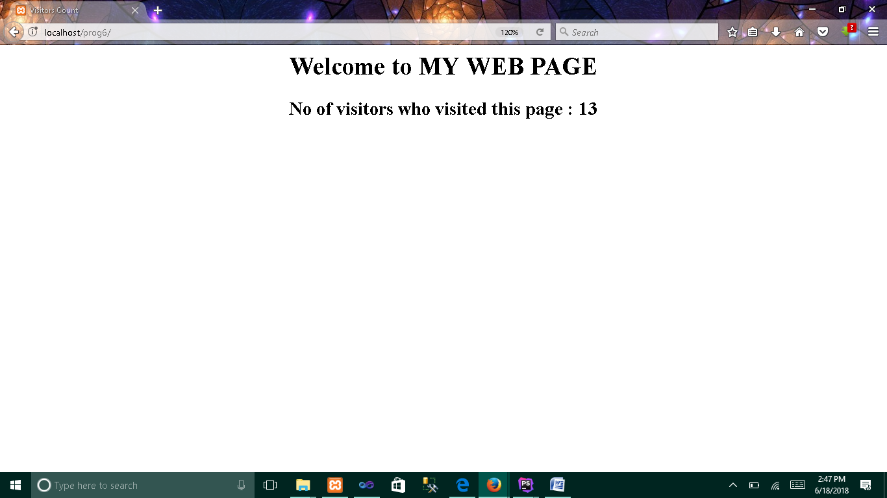

**7. Write a PHP program to display a digital clock which displays the current time of the server.**

**index.php**

**<html>  
<head>  
 <meta http-equiv="refresh" content="1">  
 <title>Digital Clock</title>  
 <style type="text/css">  
 h1 {text-align: center}  
 </style>  
</head>  
<body>  
 <?php  
 echo "<h1>Digital Clock</h1>";  
 echo "<hr/>";  
 echo "<h1>".date('h:i:s A')."</h1>";  
 echo "<hr/>";  
 ?>  
</body>  
</html>**

**Output :**

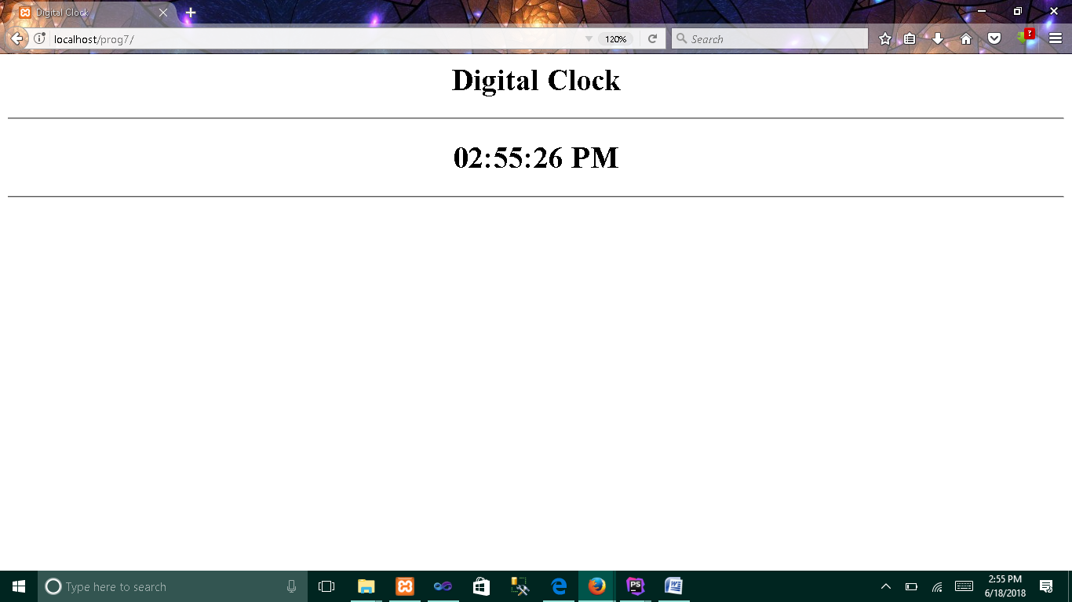

**8. Write the PHP programs to do the following:**

**a. Implement simple calculator operations.**

**b. Find the transpose of a matrix.**

**c. Multiplication of two matrices.**

**d. Addition of two matrices.**

**8a.html**

**<!DOCTYPE html>  
<html lang="en">  
<head>  
 <meta charset="UTF-8">  
 <title>Simple Calculator</title>  
</head>  
<body>  
 <form action="8a.php" method="post">  
 <h1>Simple Calculator</h1>  
 <p>First Operand: <input type="text" name="op1" /></p>  
 <p>Choose Operator:  
 <input type="radio" name="operator" checked="checked" value="+" /> Add(+)  
 <input type="radio" name="operator" value="-" /> Subtract(-)  
 <input type="radio" name="operator" value="*" /> Multiply(*)  
 <input type="radio" name="operator" value="/" /> Divide(/)  
 </p>  
 <p>Second Operand: <input type="text" name="op2"></p>  
 <p><input type="submit" name="submit" value="Submit">**

**<input type="reset" name="submit" value="Reset"></p>  
 </form>  
</body>  
</html>**

**8a.php**

**<html>  
<head>  
 <title>Result Page</title>  
 <style type="text/css">  
 h1,h2 {text-align: center}  
 </style>  
</head>  
<body>  
 <?php  
 $op1=$_POST['op1'];  
 $op2=$_POST['op2'];  
 $operator=$_POST['operator'];  
 switch($operator)  
 {  
 case '+':$res=$op1+$op2;  
 break;  
 case '-':$res=$op1-$op2;  
 break;  
 case '*':$res=$op1*$op2;  
 break;  
 case '/':if($op2==0)  
 $res=0;  
 else  
 $res=$op1/$op2;  
 break;  
 }  
 echo "<h1>Simple Calculator</h1>";  
 echo "<h2>".$op1.$operator.$op2."=".$res."</h2>";  
 ?>  
</body>**

**Output :**

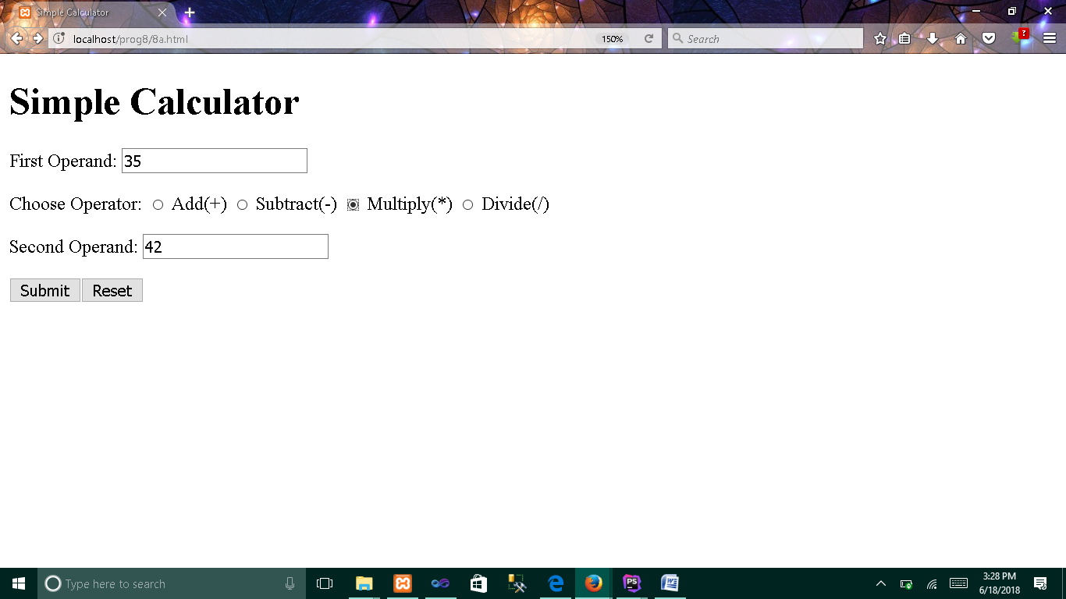

1. **HTML input page**

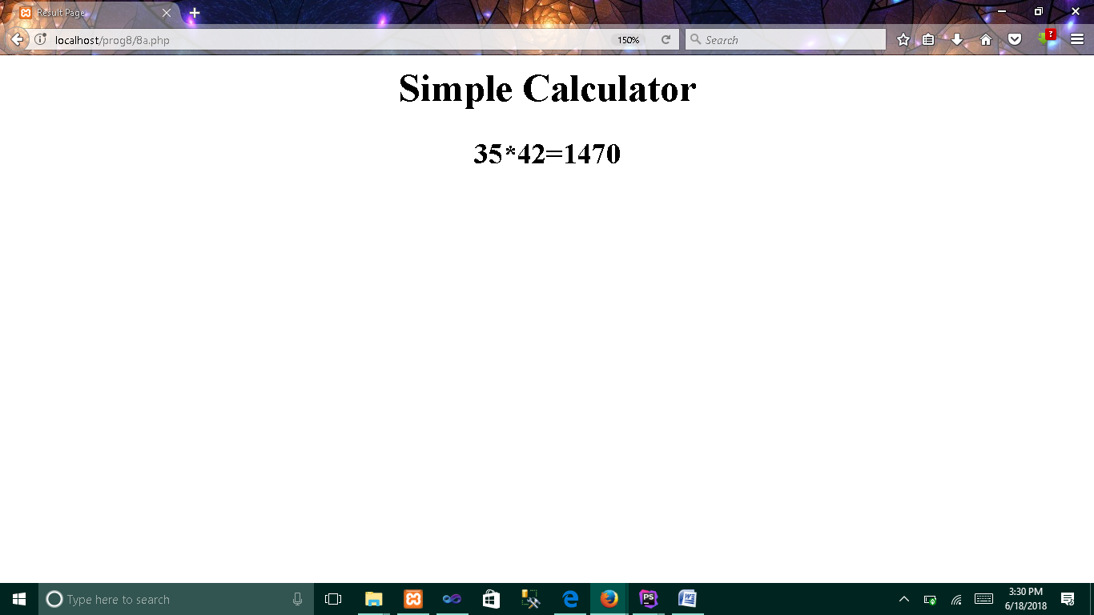

1. **PHP output/result page**

**8b.php**

**<?php  
$mat=Array(Array(1,2),  
 Array(4,5),  
 Array(7,8)); *//Initializing Array in PHP*$transpose=Array(); *//Creating empty array in PHP*  
  
echo "<html><head><title>Matrix Transpose</title></head><body>";**

**echo "<h1>Matrix is:<br/>";  
for($i = 0; $i < *count*($mat); $i++)  
{  
 for ($j = 0; $j < *count*($mat[0]); $j++)  
 {  
 echo $mat[$i][$j] . " ";  
 }  
 echo "</br/>";  
}  
echo "</h1>";  
  
  
for($i = 0; $i < *count*($mat); $i++) *//calculation for Transpose* for($j = 0; $j < *count*($mat[0]); $j++)  
 {  
 $transpose[$j][$i]=$mat[$i][$j];  
 }  
  
  
echo "<h1>Transpose of a Matrix is:<br/>";  
for($i = 0; $i < *count*($transpose); $i++)  
{  
 for ($j = 0; $j < *count*($transpose[0]); $j++)  
 {  
 echo $transpose[$i][$j] . " ";  
 }  
 echo "<br/>";  
}  
echo "</h1>";  
echo "</body></html>";**

**?>**

**Output :**

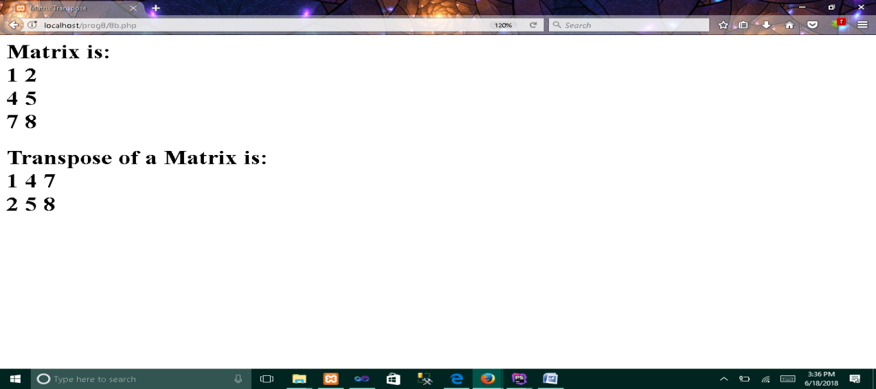

**8c.php**

**<?php  
$mat1=Array(Array(1,2),  
 Array(3,4),  
 Array(5,6)); *//initializing 2 x 3 matrix*  
  
$mat2=Array(Array(2,4,8), *//initializing 3 x* 2 matrix  
 Array(1,3,5));  
  
echo "<html><head><title>Matrix Multiplication</title></head><body>";  
  
if(*count*($mat1[0])!=*count*($mat2)) *//column(1st matrix) != row(2nd matrix)*  
{  
 echo "<h1>Incompatible Matrices</h1>";  
 exit(0);  
}  
  
$res=array();  
  
echo "<h1>Matrix A:<br/>";  
for($i = 0; $i < *count*($mat1); $i++)  
{  
 for ($j = 0; $j < *count*($mat1[0]); $j++)  
 {  
 echo $mat1[$i][$j] . " ";  
 }  
 echo "<br/>";  
}  
echo "</h1>";  
  
echo "<h1>Matrix B:<br/>";  
for($i = 0; $i < *count*($mat2); $i++)  
{  
 for ($j = 0; $j < *count*($mat2[0]); $j++)  
 {  
 echo $mat2[$i][$j] . " ";  
 }  
 echo "<br/>";  
}  
echo "</h1>";  
  
for($i = 0; $i < *count*($mat1); $i++)  
 for($j = 0; $j < *count*($mat2[0]); $j++)  
 {  
 $res[$i][$j]=0;  
 for($k=0;$k<*count*($mat2);$k++)  
 $res[$i][$j]=$res[$i][$j]+$mat1[$i][$k]*$mat2[$k][$j];  
 }  
  
echo "<h1>A x B:<br/>";  
for($i = 0; $i < *count*($res); $i++)  
{  
 for ($j = 0; $j < *count*($res); $j++)  
 {  
 echo $res[$i][$j] . " ";  
 }  
 echo "<br/>";  
}  
echo "</h1>";  
echo "</body></html>";**

**Output :**

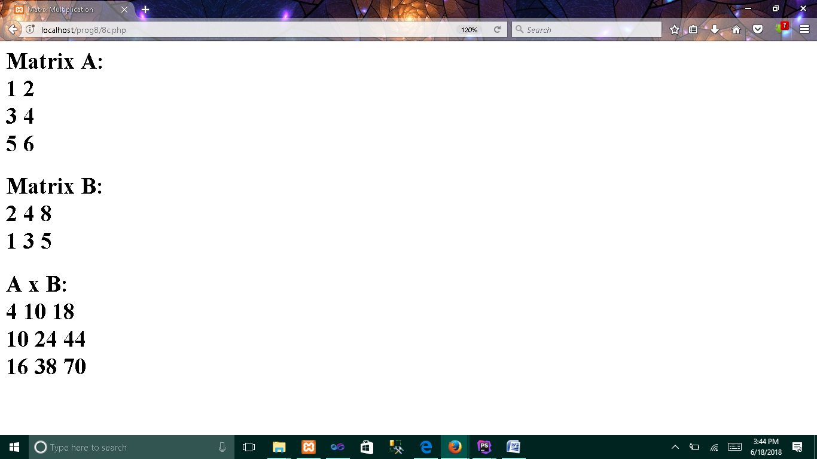

**8d.php**

**<?php  
$mat1=Array(Array(1,2),  
 Array(3,4),  
 Array(5,6));  
  
$mat2=Array(Array(1,1),  
 Array(2,2),  
 Array(3,3));**

**echo "<html><head><title>Matrix Addition</title></head><body>";  
  
if((*count*($mat1)!=*count*($mat2))||(*count*($mat1[0])!=*count*($mat2[0])))  
{  
 echo "<h1>Incompatible Matrices</h1>";  
 exit(0);  
}  
echo "<h1>Matrix A:<br/>";  
for($i=0;$i<*count*($mat1);$i++)  
{  
 for ($j = 0; $j < *count*($mat1[0]); $j++)  
 {  
 echo $mat1[$i][$j] . " ";  
 }  
 echo "<br/>";  
}  
echo "</h1>";  
  
echo "<h1>Matrix B:<br/>";  
for($i = 0; $i < *count*($mat2); $i++)  
{  
 for ($j = 0; $j < *count*($mat2[0]); $j++)  
 {  
 echo $mat2[$i][$j] . " ";  
 }  
 echo "<br/>";  
}  
echo "</h1>";  
  
$res=array();  
  
for($i = 0; $i < *count*($mat1); $i++)  
 for($j = 0; $j < *count*($mat1[0]); $j++)  
 {  
 $res[$i][$j]=$mat1[$i][$j]+$mat2[$i][$j];  
 }  
  
echo "<h1>A + B :<br/>";  
for($i = 0; $i < *count*($res); $i++)  
{  
 for ($j = 0; $j < *count*($res[0]); $j++)  
 {  
 echo $res[$i][$j] . " ";  
 }  
 echo "<br/>";  
}  
echo "</h1>";**

**Output :**

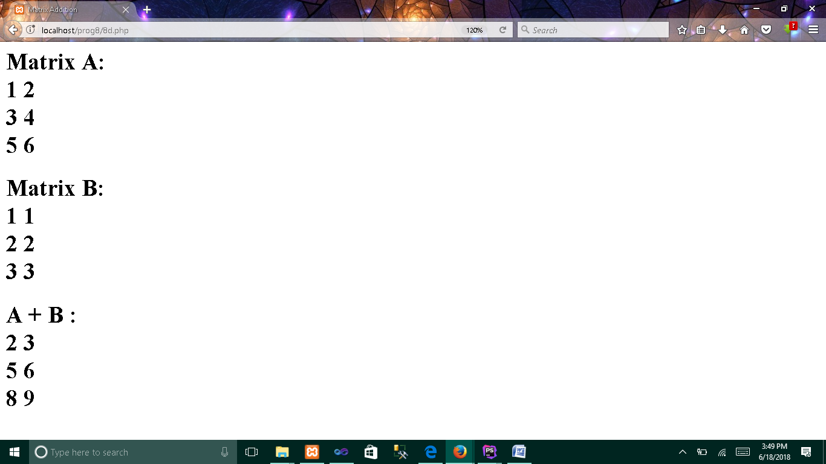

**9. Write a PHP program named states.py that declares a variable states with value "Mississippi Alabama Texas Massachusetts Kansas". write a PHP program that does the following:**

1. **Search for a word in variable states that ends in xas. Store this word in element 0 of a list named statesList.**
2. **Search for a word in states that begins with k and ends in s. Perform a case-insensitive comparison. [Note: Passing re.Ias a second parameter to method compile performs a case-insensitive comparison.] Store this word in element1 of statesList.**
3. **Search for a word in states that begins with M and ends in s. Store this word in element 2 of the list.**
4. **Search for a word in states that ends in a. Store this word in element 3 of the list.**

**index.php**

**<html>  
<head>  
 <title>Pattern Matching using python</title>  
</head>  
<body>  
 <?php  
 $res=shell_exec("python PythonServer/states.py");  
 $states=explode("\n",$res); *//in python print embed \n at the end*  
 echo "Statement is : <b>$states[4]</b><br/>";  
 echo "Word that end with xas : <b>$states[0]</b><br/>";  
 echo "Word that Starts with k and end with s (Case Insensitive): <b>$states[1]</b><br/>";  
 echo "Word that Starts with M and end with s : <b>$states[2]</b><br/>";  
 echo "Word that end with a : <b>$states[3]</b>";  
 ?>  
</body>  
</html>**

**States.py**

**import re   
states="Mississippi Alabama Texas Massachusetts Kansas"  
statesArr=states.split() # splits the sentence into words  
statesList=list() # Creates an empty List**

**for val in statesArr:  
 if(re.search('xas$',val)): #note: Indentation is imp in python  
 statesList.append(val)  
  
for val in statesArr:  
 if(re.search('^k.*s$',val,re.I)):  
 statesList.append(val)  
  
for val in statesArr:  
 if(re.search('^M.*s$',val)):  
 statesList.append(val)  
  
for val in statesArr:  
 if(re.search('a$',val)):  
 statesList.append(val)  
for val in statesList:  
 print(val)**

**print(states);**

**Instruction :**

**Install Python in terminal / command prompt.**

**Create a folder named “PythonServer” in the same directory where “index.php” has been located. And then place the “states.py” file inside “PythonServer” folder.**

**This is to assume that “state.py” has been fetched from some python server, which has been located somewhere on the internet.**

**Output :**

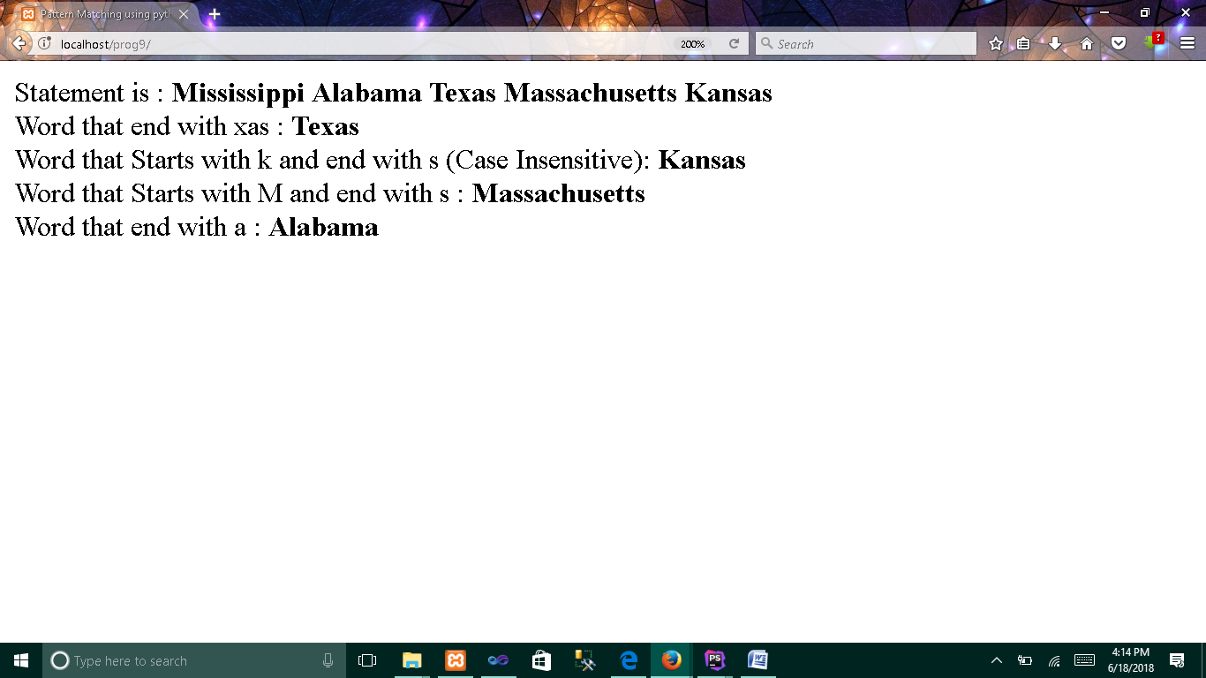

**10. Write a PHP program to sort the student records which are stored in the database using selection sort.**

**index.php**

**<html>  
<head>  
 <title>Select Sort on student records</title>  
 <style type="text/css">  
 h1 {text-align: center}  
 </style>  
</head>  
<body>  
 <h1>Selection Sort on sample student data</h1>**

**<form action="" method="post">  
 <h1>Sort By :  
 <select name="field">  
 <option value="" disabled selected>Choose Field</option>  
 <option value="name">Name</option>  
 <option value="usn">USN</option>  
 <option value="year">Year</option>  
 <option value="marks">Marks</option>  
 <option value="coll">College</option>  
 </select>  
 </h1>  
 <h1>  
 <input type="submit" name="submit" value="Submit">  
 <input type="reset" name="reset" value="Reset">  
 </h1>  
 </form>**

**<?php  
 function selection_sort($data,$keys)  
 {  
 for($i=0; $i<*count*($data)-1; $i++)  
 {  
 $min = $i;  
 for($j=$i+1; $j<*count*($data); $j++)  
 {  
 if ($data[$j]<$data[$min])  
 {  
 $min = $j;  
 }  
 }  
 $data = swap_positions($data, $i, $min);  
 $keys = swap_positions($keys, $i, $min);  
 }  
 return $keys;  
 }  
  
 function swap_positions($data1, $left, $right)  
 {  
 $temp = $data1[$right];  
 $data1[$right] = $data1[$left];  
 $data1[$left] = $temp;  
 return $data1;  
 }  
 include 'sql.php';  
 $str="select *\** from studentdetails";  
 $res=*mysqli_query*($sql,$str);  
 $field="none";  
 $myarr=[];  
 $original=[];  
 $i=1;  
 while($arr=*mysqli_fetch_assoc*($res))  
 {  
 $myarr[]=$arr;  
 }  
 if(isset($_POST['submit']) && isset($_POST['field']))  
 {  
 $field=$_POST['field'];  
 $original=array_column($myarr,$field,'id');**

***// Create Associate array with (key,value)=('id',$feild)***

**$orginalKey=array_keys($original);  
$originalVal=array_values($original);  
$sortedkeys=selection_sort($originalVal,$orginalKey);**

**$myarr=[];  
 foreach ($sortedkeys as $key)  
 {  
 $str="select *\** from studentdetails WHERE id='$key'";  
 $res=*mysqli_query*($sql,$str);  
 $myarr[]=*mysqli_fetch_assoc*($res);  
 }  
 }  
 ?>  
 <table border="1" width="80%" align="center">  
 <tr>  
 <th colspan="6">**

**Student Details [Sorted by: <?php echo $field;?>]**

**</th>  
 </tr>  
 <tr>  
 <th>No</th>  
 <th>Name</th>  
 <th>USN</th>  
 <th>Year</th>  
 <th>Marks</th>  
 <th>College</th>  
 </tr>  
 <?php foreach ($myarr as $arr): ?>  
 <tr>  
 <td><?php echo $i++; ?></td>  
 <td><?php echo $arr['name']; ?></td>  
 <td><?php echo $arr['usn']; ?></td>  
 <td><?php echo $arr['year']; ?></td>  
 <td><?php echo $arr['marks']; ?></td>  
 <td><?php echo $arr['coll']; ?></td>  
 </tr>  
 <?php endforeach; ?>  
 </table>  
</body>  
</html>**

**sql.php**

**<?php  
$sql=*mysqli_connect*("localhost","root","","prog10");  
?>**

**Database Procedure :**

1. **Creating Database :  
   CREATE DATABASE prog10;**

**2. Creating table :  
 CREATE TABLE studentdetails (  
 id int AUTO_INCREMENT,  
 name varchar(100),  
 usn varchar(50),  
 year int,  
 marks int,  
 coll varchar(200),  
 PRIMARY KEY (id)**

**);  
  
3. Insert 5 sample data into table :  
 INSERT INTO studentdetails VALUES  
 (0,'Raj','4sh12cs001',2012,75,'Shree Devi Institute of Tech'),  
 (0,'Suresh','4sh10cs002',2010,55,'Shree Devi Institute of Tech'),  
 (0,'Ram','4sr11cs001',2011,75,'Srinivas Institute of Tech'),  
 (0,'Som','4sj15cs001',2015,35,'StJoseph Collge of Engg'),  
 (0,'Bhim','4ca14cs001',2014,75,'Canara Collage of Engg');**

**Output :**

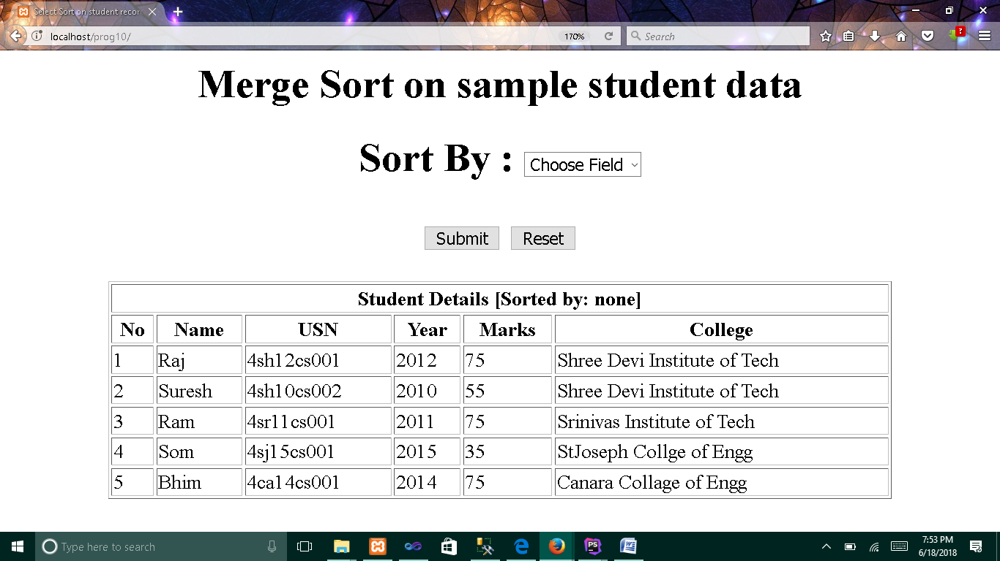

1. **Without applying any sort**

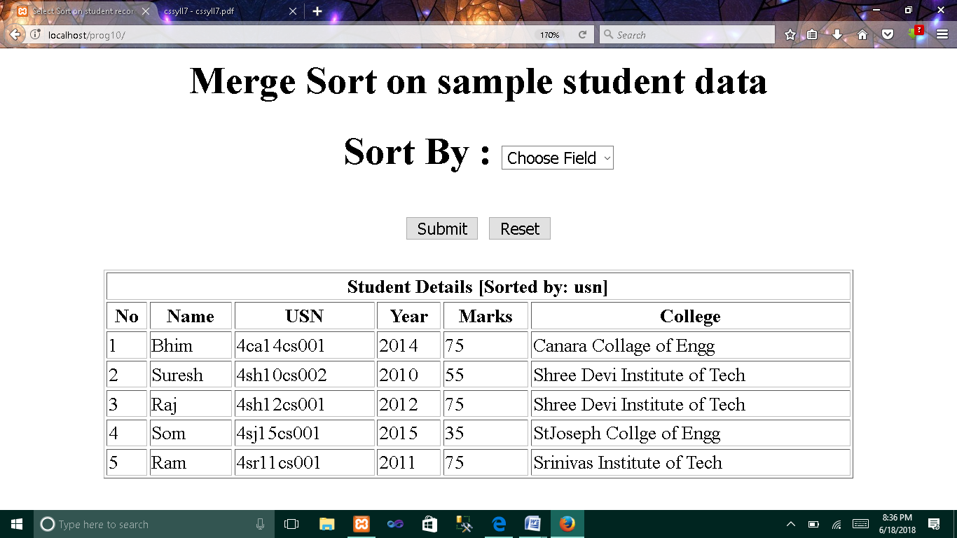

1. **Sorting the data based on USN**

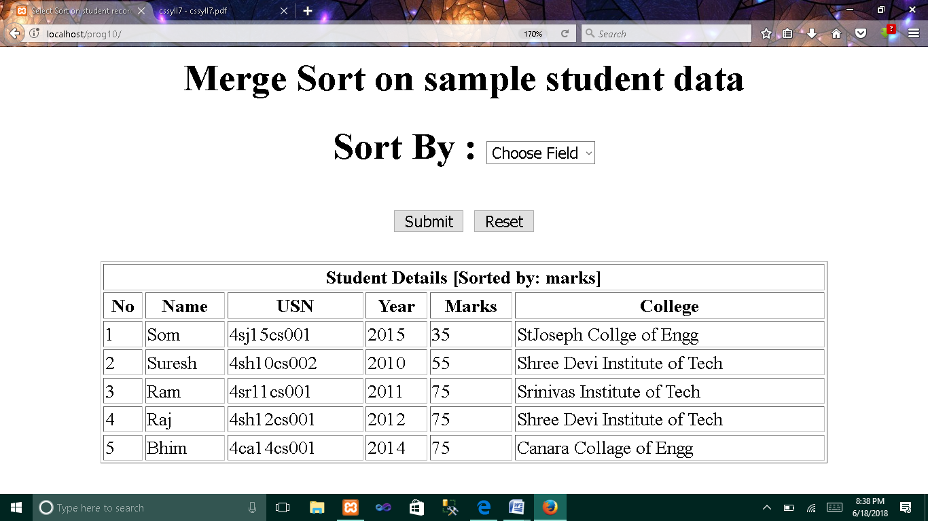

1. **Sorting the data based on MARKS**

**10. Write a PHP program to sort the student records which are stored in the database using selection sort.**

**USING ANGULAR JS**

**Note :**

1. **Must need to include angular.min.js file.**
2. **Database is similar to previous program**

**index.html**

**<!DOCTYPE html>  
<html lang="en" ng-app="myApp">  
<head>  
 <meta charset="UTF-8">  
 <title>Title</title>  
 <script src="angular.min.js"></script>  
 <script>  
 var app=angular.module('myApp',[]);  
 app.controller('myContr',function ($scope,$http)**

**{  
 $http.get("getDetails.php").then(function (response)**

**{  
 $scope.details=response.data;  
 })  
  
 });  
 </script>  
 <style>  
 h1,form {text-align: center}  
 </style>  
</head>  
<body ng-controller="myContr">  
<h1>Selection Sort on sample student data</h1>  
<h1>  
 Sort By :  
 <select required name="field" ng-model="field">  
 <option value="" disabled selected>Choose Field</option>  
 <option value="name">Name</option>  
 <option value="usn">USN</option>  
 <option value="year">Year</option>  
 <option value="marks">Marks</option>  
 <option value="coll">Collage</option>  
 </select>  
</h1>  
<table border="1" width="80%" align="center">  
 <tr>  
 <th colspan="6">Student Details [Sorted by: {{field}}]</th>  
 </tr>  
 <tr>  
 <th>No</th>  
 <th>Name</th>  
 <th>USN</th>  
 <th>Year</th>  
 <th>Marks</th>  
 <th>College</th>  
 </tr>  
 <tr ng-repeat="d in details|orderBy:field:false">  
 <td>{{$index+1}}</td>  
 <td>{{d.name}}</td>  
 <td>{{d.usn}}</td>  
 <td>{{d.year}}</td>  
 <td>{{d.marks}}</td>  
 <td>{{d.coll}}</td>  
 </tr>  
</table>  
</body>  
</html>**

**getDetails.php**

**<?php  
include 'sql.php';  
$str="select * from studentdetails";  
$res=mysqli_query($sql,$str);  
$i=0;  
$myarr=[];  
while($arr=mysqli_fetch_assoc($res))  
{  
 $myarr[$i++]=$arr;  
}  
echo json_encode($myarr);**

**sql.php**

**<?php  
$sql=*mysqli_connect*("localhost","root","","prog10");  
?>**